LAPORAN PENGERJAAN UJI KOMPETENSI KEJURUAN SMK MAHARDHIKA BATUJAJAR

TAHUN PELAJARAN 2022-2023

KOMPETENSI KEAHLIAN : Rekayasa Perangkat Lunak KELAS : XII RPL2

NAMA LENGKAP : Veldy Nurohman

NIS : 2021.10.367

PAKET SOAL : 02

JENIS APLIKASI : Web

ALOKASI WAKTU : 24 jam

# PENJADWALAN KEGIATAN

|  |  |  |  |  |  |  |  |  |  |  |  |
| --- | --- | --- | --- | --- | --- | --- | --- | --- | --- | --- | --- |
| **KEGIATAN** | **ALOKASI WAKTU** | | | | | | | | | | **KETERANGAN** |
| **JANUARI** | | | | **FEBRUARI** | | | | **MARET** | |
|
| **Tgl 1-6** | **Tgl 8-13** | **Tgl 15-21** | **Tgl 22-30** | **Tgl 1-6** | **Tgl 8-13** | **Tgl 15-21** | **Tgl 23-29** | **Tgl 1-6** | **Tgl 8-11** |
| Analisa Soal |  |  |  |  |  |  |  |  |  |  |  |
| Persiapan Perangkat Keras |  |  |  |  |  |  |  |  |  |  |  |
| Persiapan Perangkat Lunak |  |  |  |  |  |  |  |  |  |  |  |
| Perancangan Algoritma |  |  |  |  |  |  |  |  |  |  |  |
| Desain Bisnis Data |  |  |  |  |  |  |  |  |  |  |  |
| Implementasi Data Ke Mysql |  |  |  |  |  |  |  |  |  |  |  |
| Desain UI |  |  |  |  |  |  |  |  |  |  |  |
| coding Srtuktur HTML |  |  |  |  |  |  |  |  |  |  |  |
| Coding Style CSS |  |  |  |  |  |  |  |  |  |  |  |
| Coding PHP |  |  |  |  |  |  |  |  |  |  |  |
| Uji Coba Aplikasi |  |  |  |  |  |  |  |  |  |  |  |
| Uji Coba Cetak Struk |  |  |  |  |  |  |  |  |  |  |  |
| UJI Coba Buat Laporan |  |  |  |  |  |  |  |  |  |  |  |
| Upload Ke Hosting |  |  |  |  |  |  |  |  |  |  |  |
| Dokumentasi |  |  |  |  |  |  |  |  |  |  |  |

# PERSIAPAN PERANGKAT KERAS

|  |  |
| --- | --- |
| 1 | Processor IntelCore Duo CPU E7500 @ 2.93 GHz 2.92 GHz |
| 2 | RAM 6 GB |
| 3 | Monitor |
| 4 | Keyboard |
| 5 | Mouse |
| 6 | Casing CPU |

# PERSIAPAN PERANGKAT LUNAK

|  |  |
| --- | --- |
| 1 | Visual Studio Code |
| 2 | Sublime Text |
| 3 | XAMPP Control Panel |
| 4 | Balsamiq |
| 5 | Astah Pro |
| 6 | Chrome |
| 7 | Microsoft Word |
| 8 | Microsoft excel |

# PERANCANGAN ALGORITMA APLIKASI

# 1.login

Gambar 1 Login.

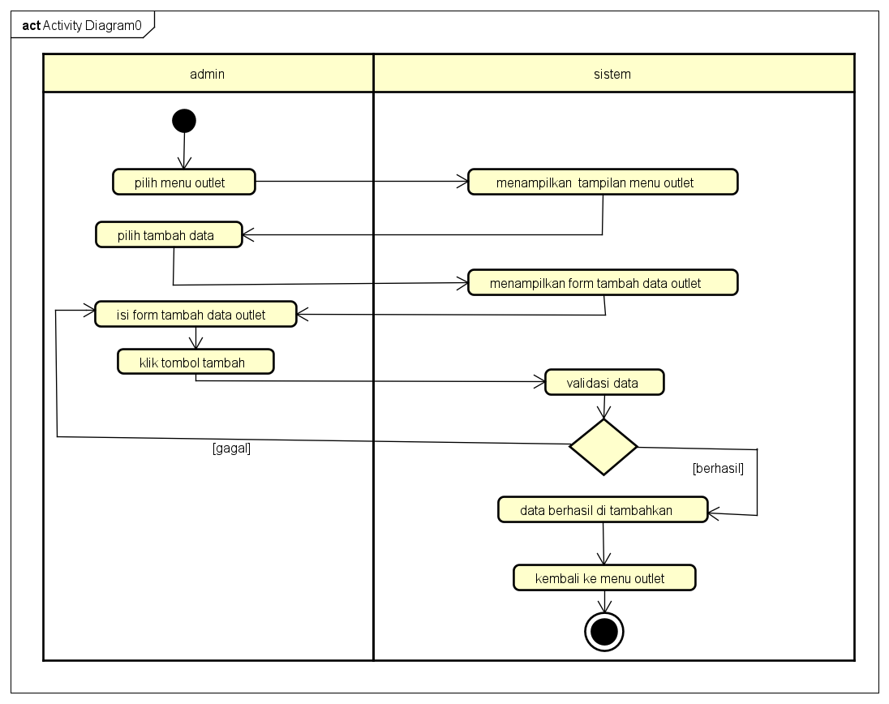

Gambar 2 Tambah Outlet.

Gambar 3 Edit Outlet.

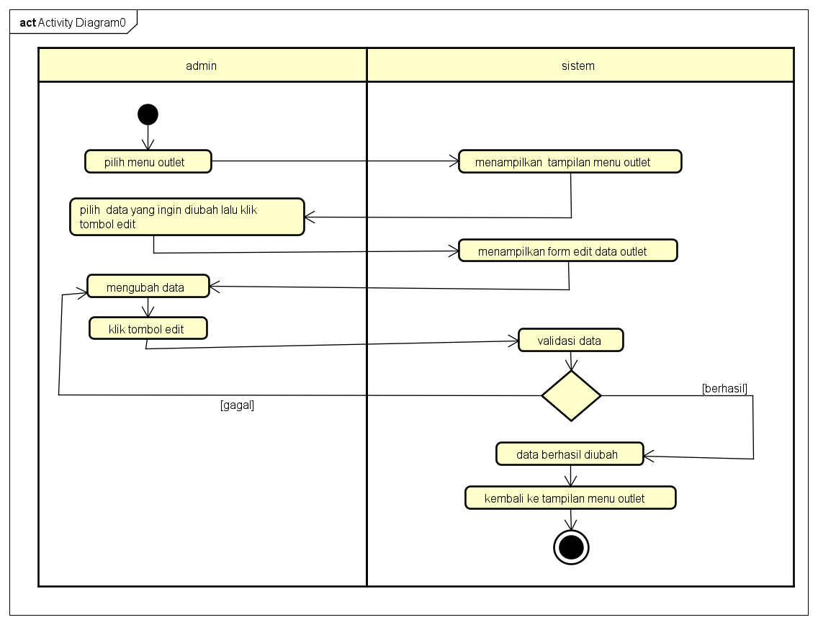

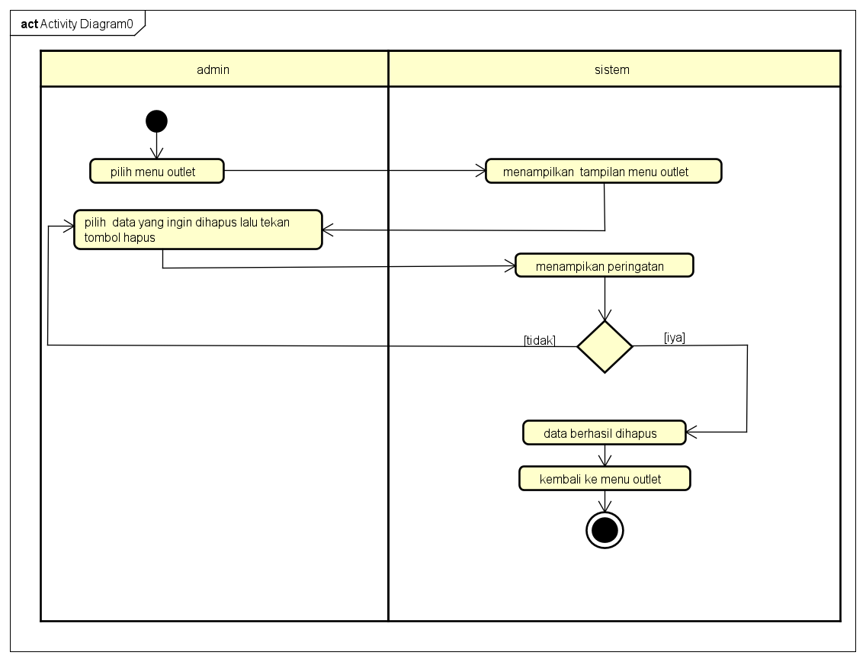

Gambar 4 Hapus Outlet.

2.Paket

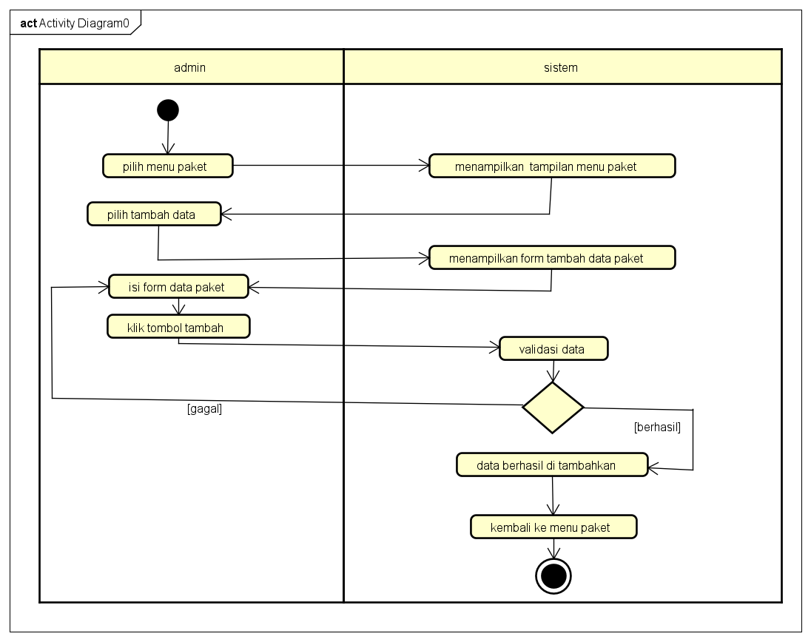

Gambar 5 Tambah Paket.

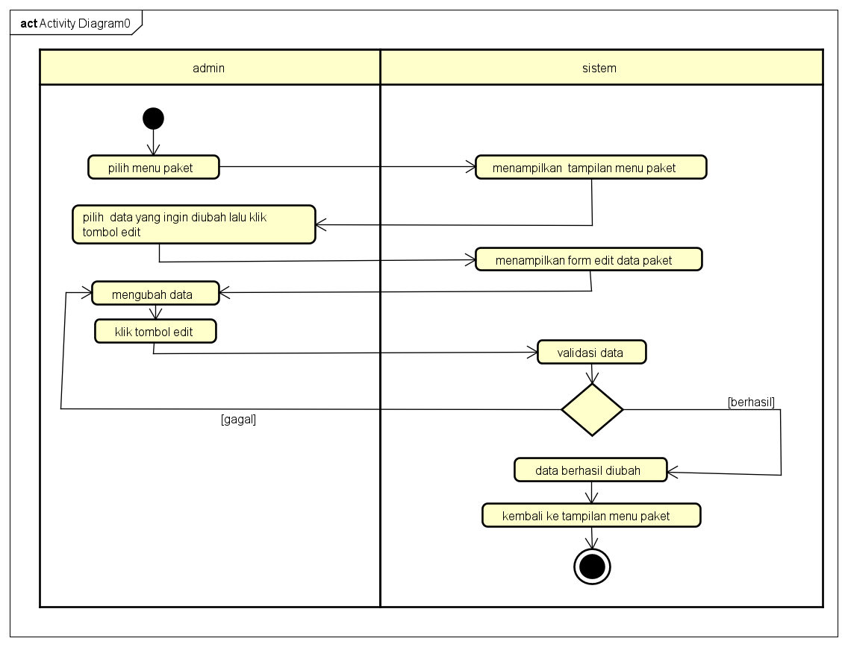

Gambar 6 Edit Paket.

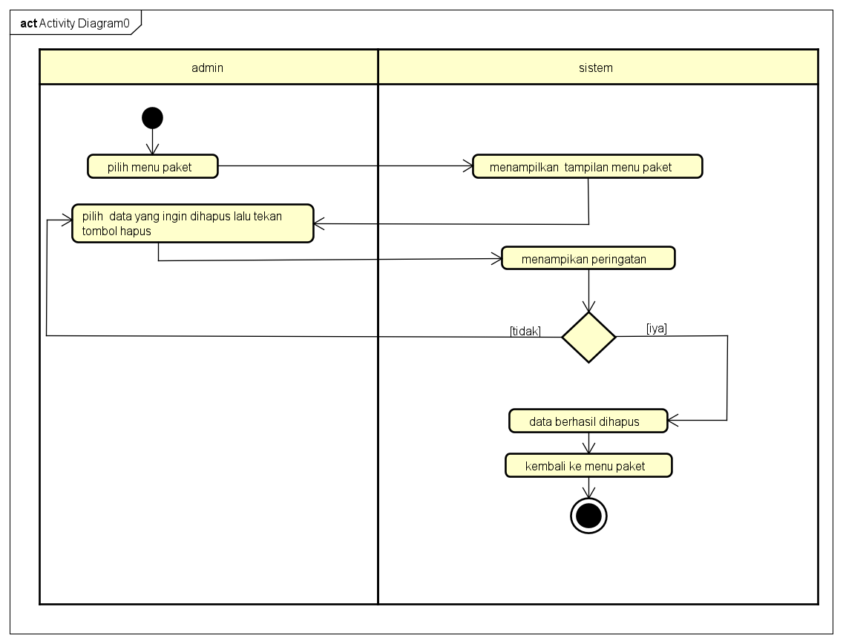

Gambar 7 Hapus Edit.

3.Pelanggan

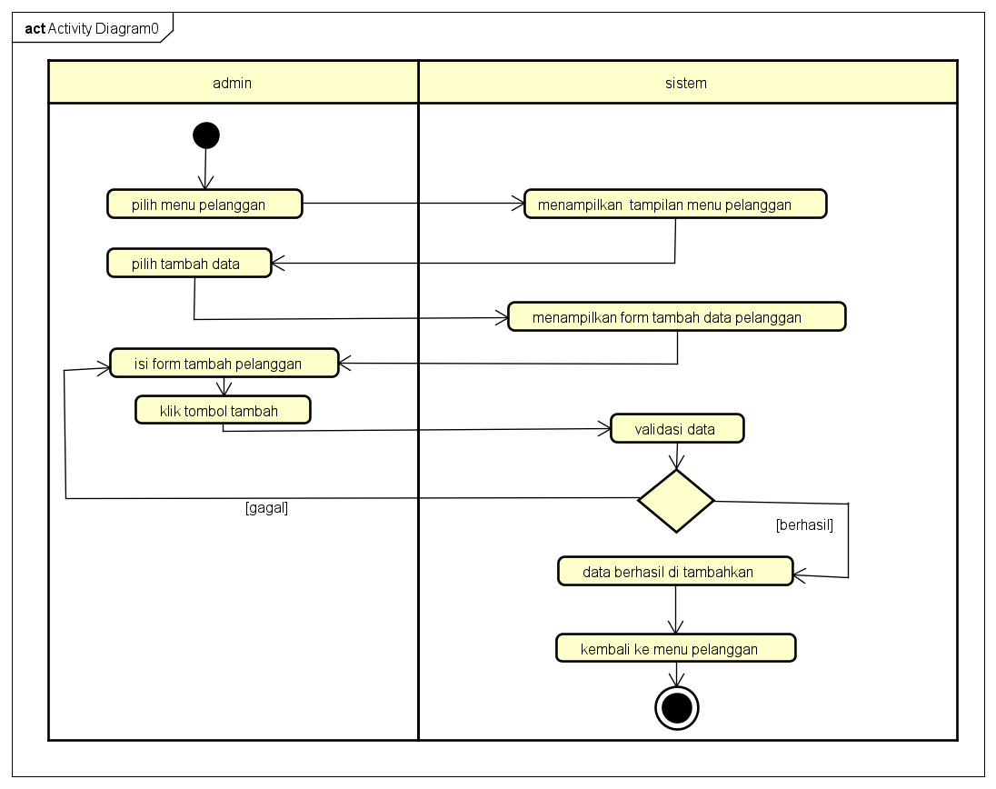

Gambar 8 Tambah Pelanggan.

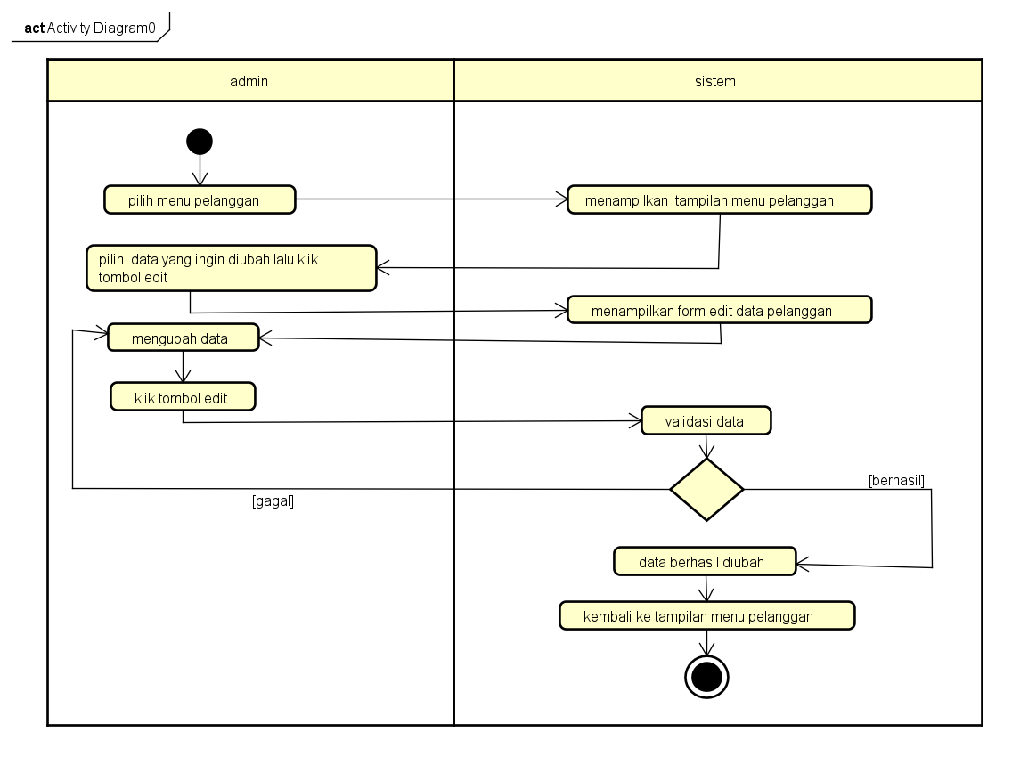

Gambar 9 Edit Pelanggan.

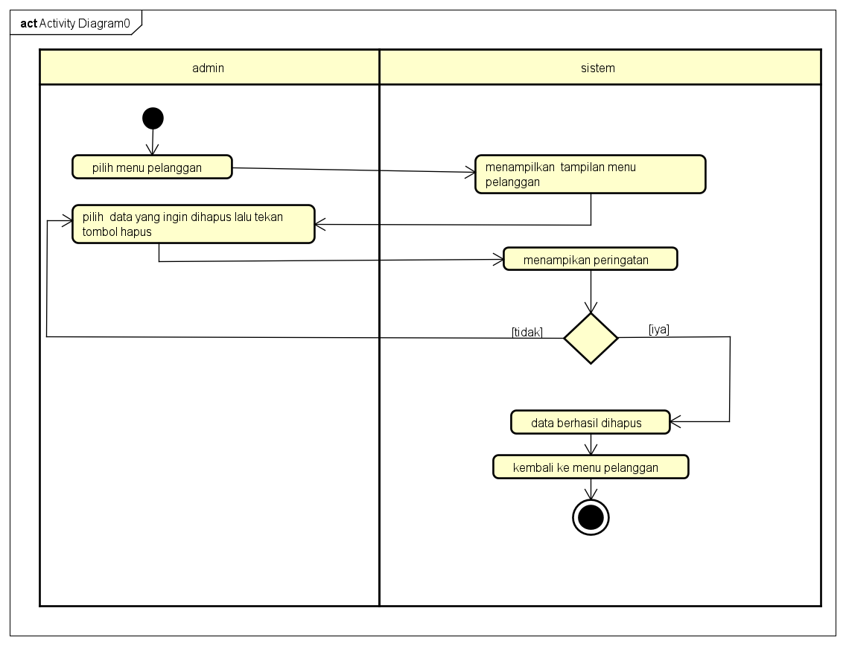

Gambar 10 Hapus Pelanggan.

4.Pengguna

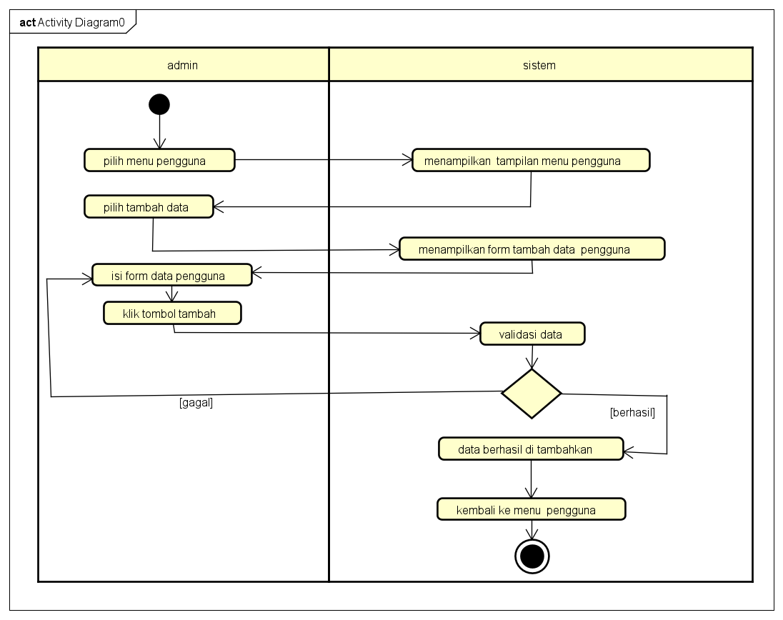

Gambar 11 Tambah Pengguna.

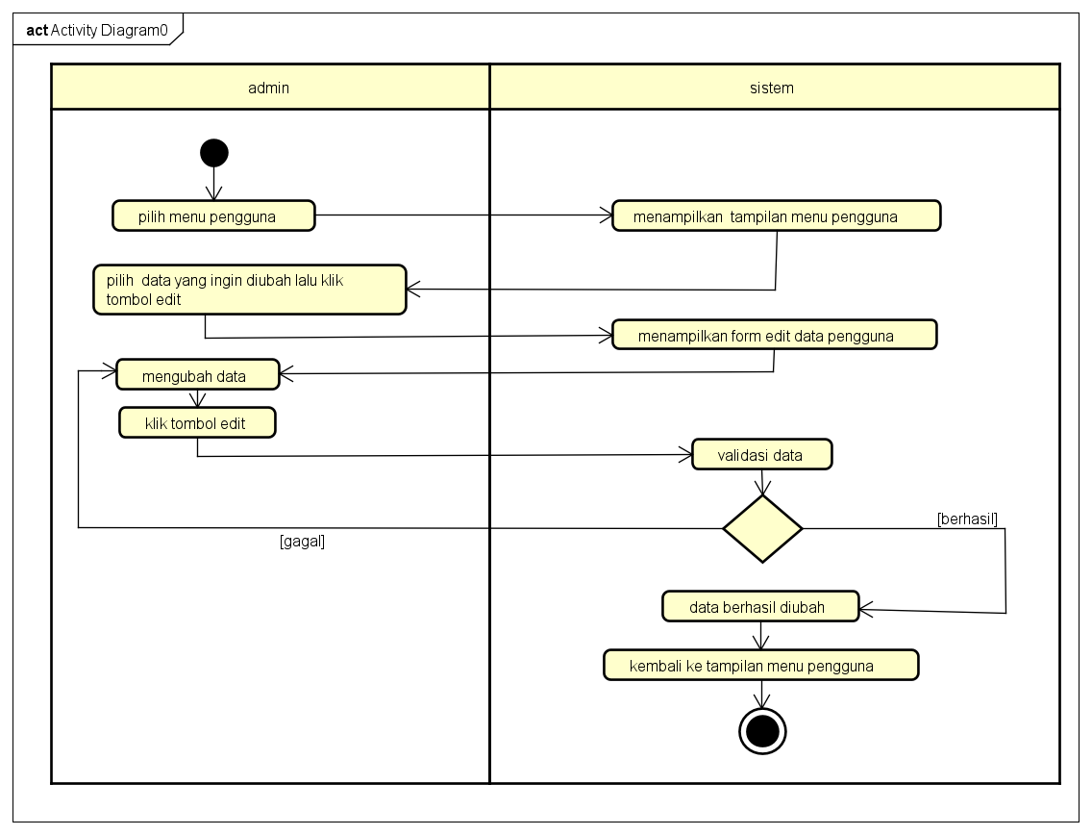

Gambar 12 Edit Pengguna.

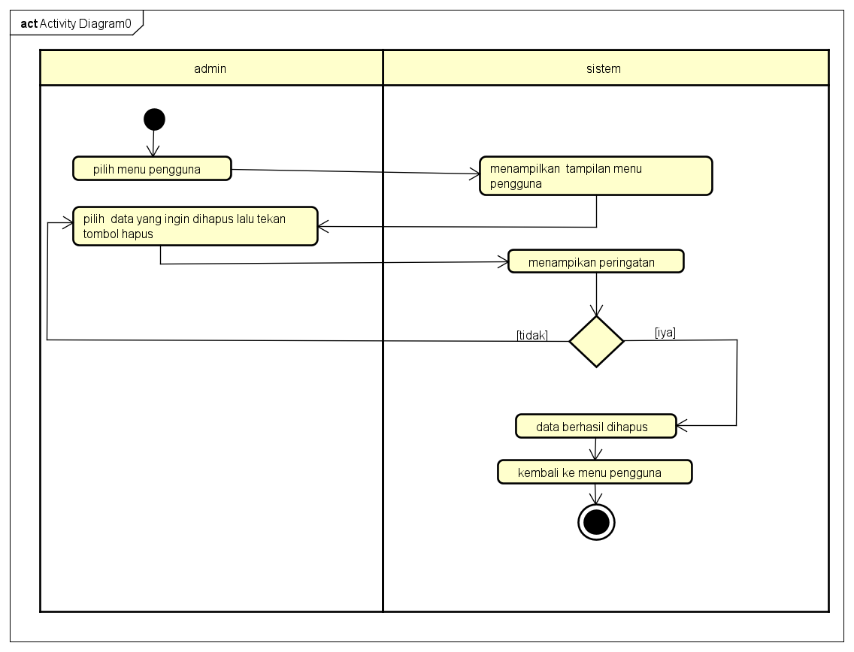

Gambar 13 Hapus Pengguna.

5.Transaksi

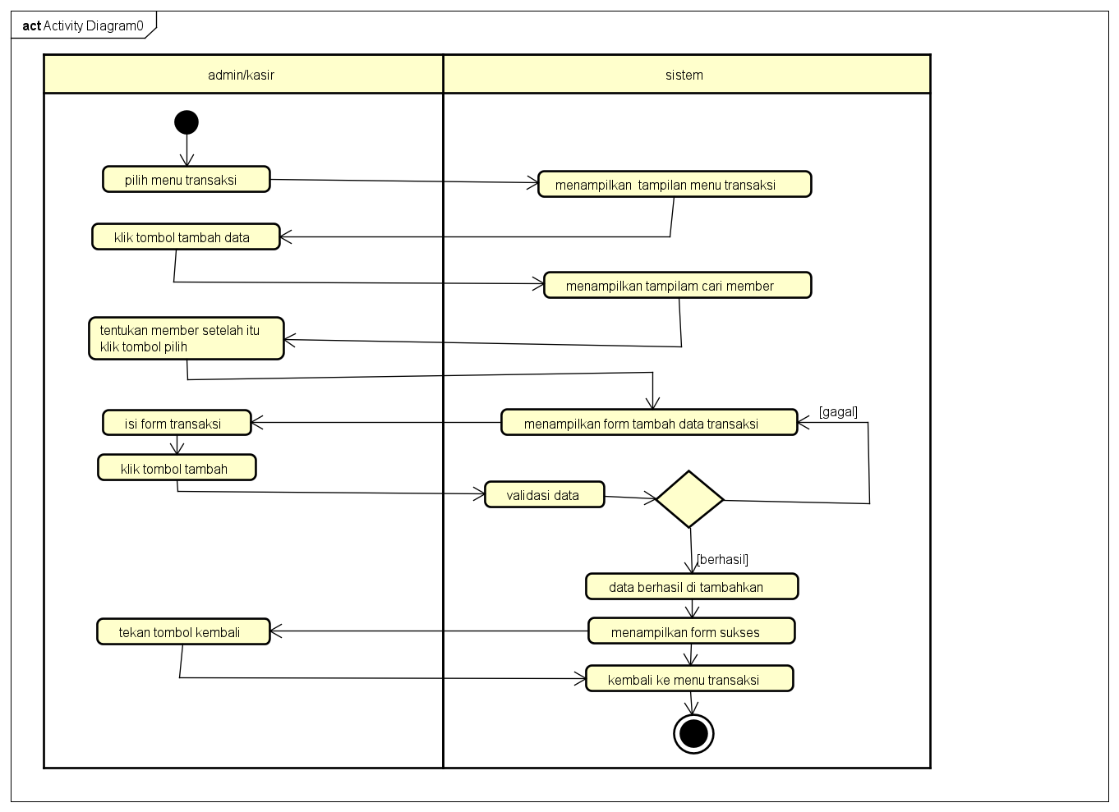

Gambar 14 Tambah Tansaksi.

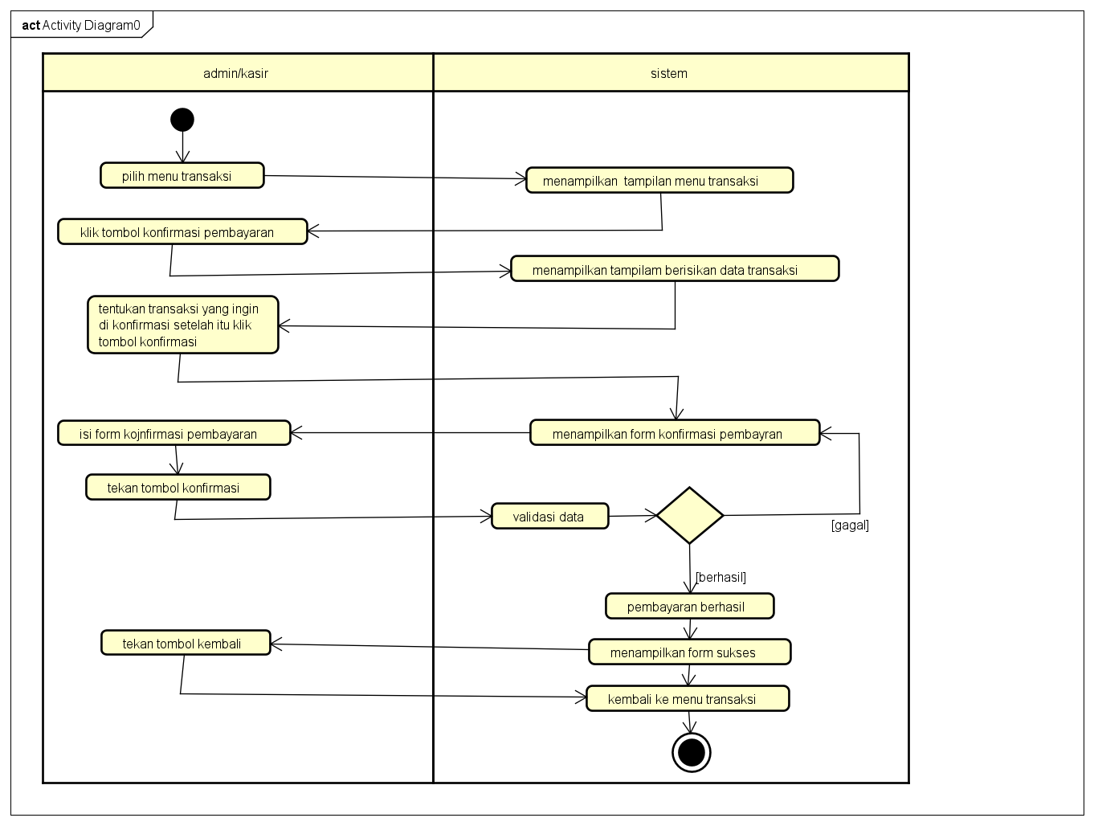

Gambar 15 Konfirmasi Transaksi.

6.Cetak Laporan

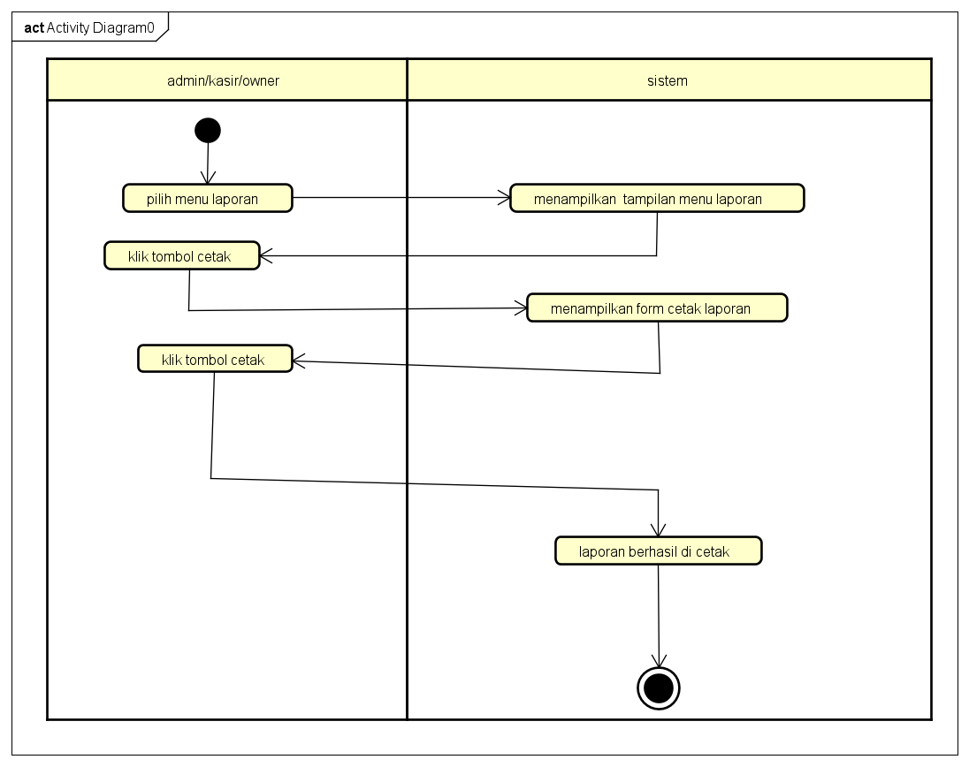

Gambar 16 Cetak Laporan.

7.Logout

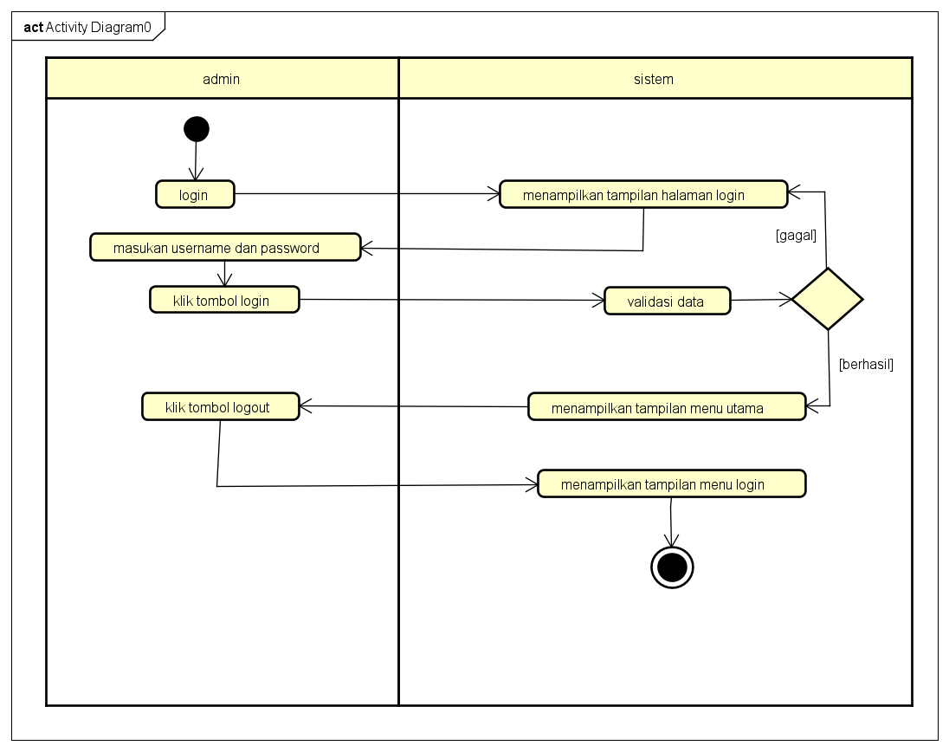

Gambar 17 Logout.

# PERANCANGAN DESAIN BASIS DATA

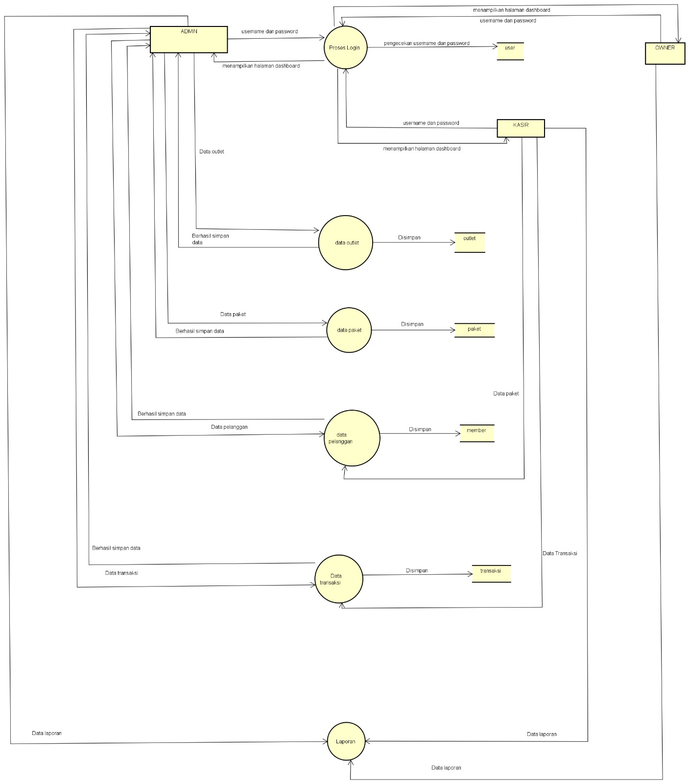

Gambar 18 Data Flow Diagram(DFD).

# DUMMY DATA

# 1.Outlet

|  |  |  |  |
| --- | --- | --- | --- |
| Id_outlet | Nama_outlet | Alamat_outlet | Telp_outlet |
| 26 | Outlet Cantik | Cirebon | 000000000002 |
| 29 | Outlet Bersih | kuningan | 098777447773 |

2.Paket

|  |  |  |  |  |
| --- | --- | --- | --- | --- |
| Id_paket | Jenis_paket | Nama_paket | Harga | Outlet_id |
| 4 | Kiloan | Paket cuci kering | 7000 | 26 |
| 5 | Kiloan | Paket cuci setrika | 9000 | 26 |
| 6 | Kiloan | Paket setrika | 6000 | 26 |
| 7 | Badcover | Paket badcover | 11000 | 26 |
| 8 | Kiloan | Paket one day service (ODS) | 14000 | 26 |
| 9 | Kiloan | Paket exspress service(6 jam) | 21000 | 26 |

3.Pengguna

|  |  |  |  |  |  |
| --- | --- | --- | --- | --- | --- |
| Id_user | Nama_user | username | password | Outlet_id | role |
| 1 | Admin | Admin | - | - | Admin |
| 16 | Owner | Owner | - | 26 | Owner |
| 18 | Kasir | Kasir | - | - | kasir |

4.Member

|  |  |  |  |  |  |
| --- | --- | --- | --- | --- | --- |
| Id_member | Nama_member | Alamat_member | Jenis_kelamin | Telp_member | No_ktp |
| 5 | Susi | Cirebon | p | 0000000001 | 0000000001 |
| 6 | Mely | Cirebon | p | 0000000002 | 0000000002 |
| 7 | Neni | Cirebon | p | 0000000003 | 0000000003 |
| 8 | Ako | Cirebon | L | 08998 | 0899332 |
| 9 | jono | Cirebon | L | 08998444333 | 320939399200 |

# PEMBUATAN BASIS DATA (MySQL Code)

# 

Gambar 19 detail transaksi.

# 

Bagan 20 member.

# 

Bagan 21 outlet.

# 

Bagan 22 paket.

# 

Bagan 23 transaksi.

# 

Bagan 24 user.

# PERANCANGAN TAMPILAN ANTARMUKA (UI) WEB

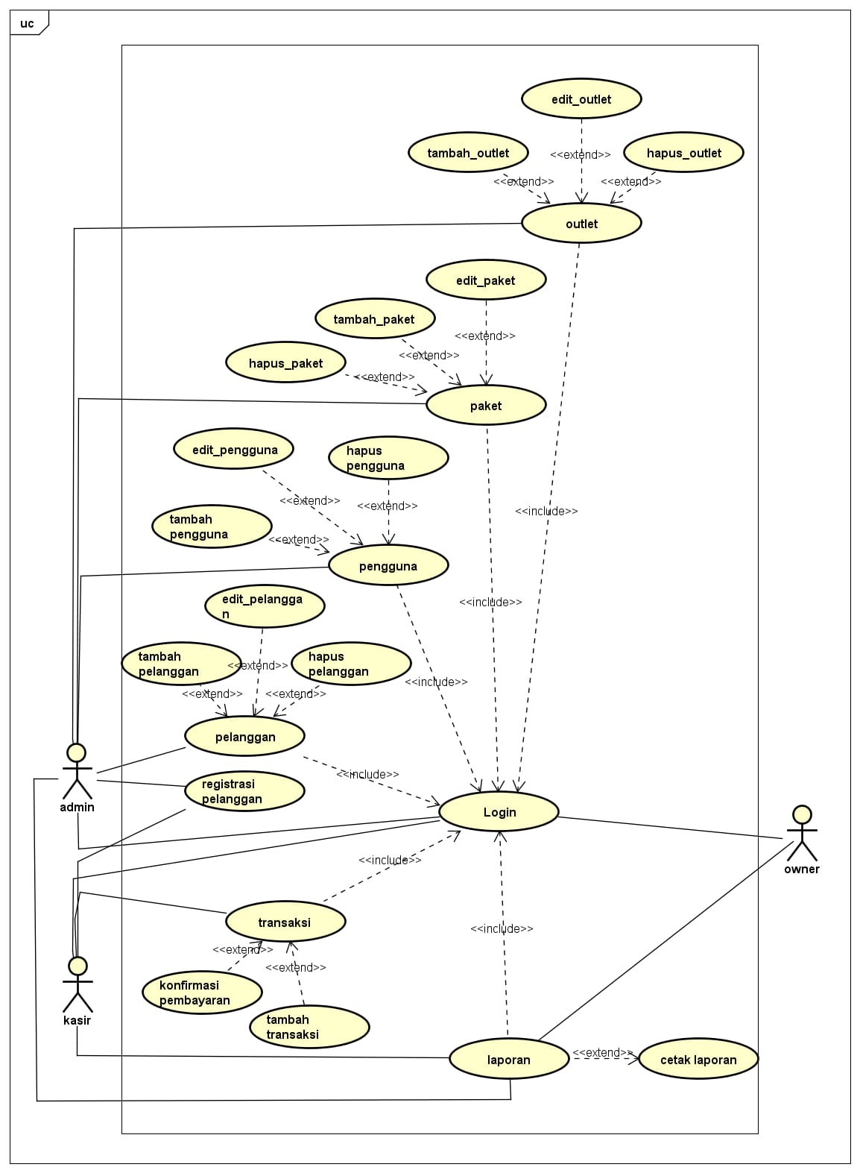

Gambar 25 Usecase Diagram.

# Aplikasi pengelolaan laundry

**1.Admin**

a.login

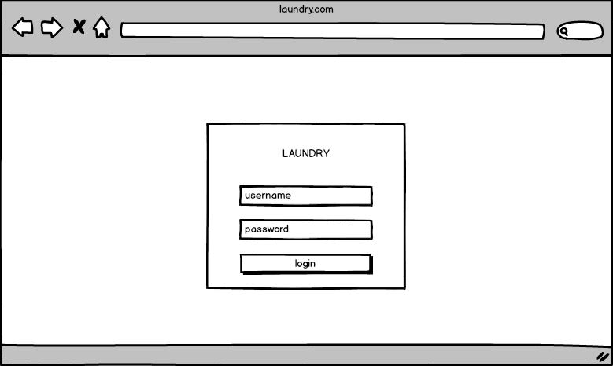

Gambar 26 login admin.

b.Dashboard

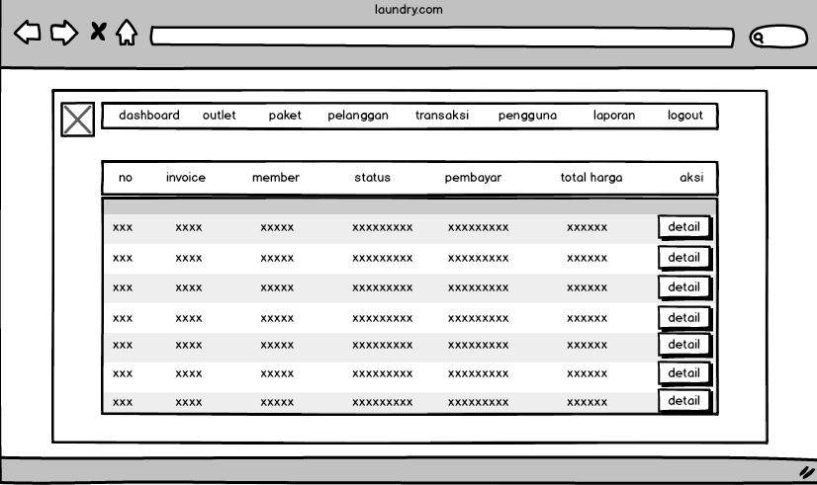

Gambar 27 Dashboard admin.

c.

c.Pelanggan

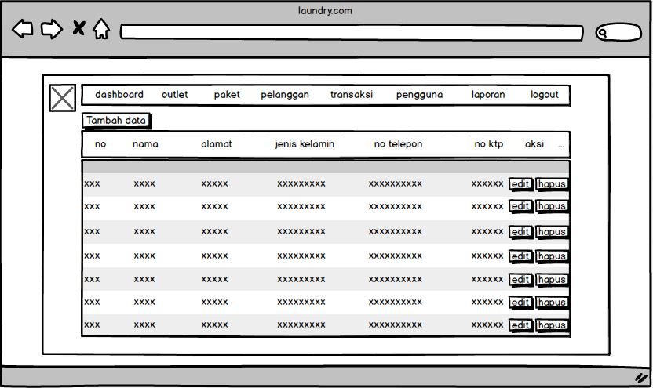

Gambar 28 pelanggan admin.

2.Kasir

a.Dashboard Kasir

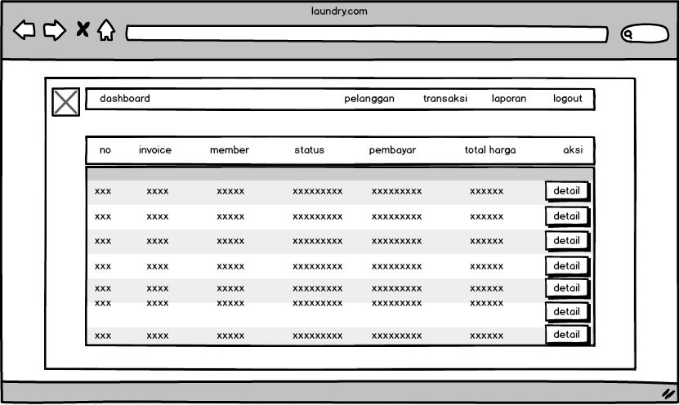

Gambar 29 Dashboard Kasir.

# 

# B.Pelanggan Kasir

# 

# 

Gambar 30 Pelanggan Kasir.

3.Owner

a.Dashborad Owner

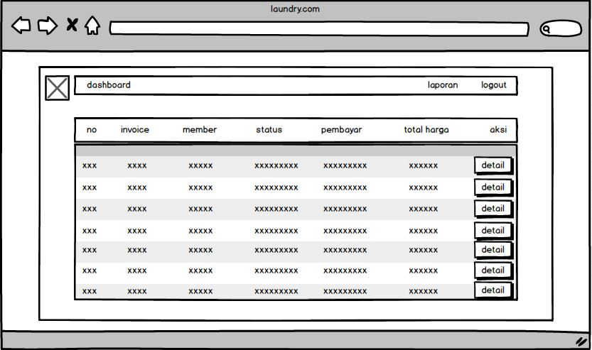

Gambar 31 Dashborad Owner.

# b.Laporan Owner

# 

Gambar 32 Laporan Owner.

# PEMBUATAN STRUKTUR WEB (HTML)

# Transaksi.php

|  |
| --- |
| <!DOCTYPE html>  <html lang="en">  <head>  <link href="../css/tabelc.css?version=<?= filemtime("../css/tabelc.css")?>" rel="stylesheet">  </head>  <body>  <?php  $title = 'transaksi';  require 'functions.php';  require 'navbar.php';  $query = "SELECT transaksi.*,member.nama_member , detail_transaksi.total_harga FROM transaksi INNER JOIN member ON member.id_member = transaksi.member_id INNER JOIN detail_transaksi ON detail_transaksi.transaksi_id = transaksi.id_transaksi ";  $data = ambildata($conn,$query);  ?>   <div>                          <a href="transaksi_cari_member.php"><button class="btn2"> Tambah Data</button>                          <a href="transaksi_konfirmasi.php"><button class="btn2"> konfirmasi pembayaran</button>                      </div>  <table>       <thead>          <tr>          <th><label>no </label></th>            <th><label>Invoice</label></th>            <th><label>member</label></th>            <th><label>status</label></th>            <th><label>pembayaran</label></th>            <th><label>total harga</label></th>            <th width="15%"><label>Aksi</label></th>          </tr>        </thead>        <tbody>        <?php $no=1; foreach($data as $transaksi): ?>          <tr class="data-label">               <td><?= $no++ ?></td>              <td><?= $transaksi['kode_invoice'] ?></td>              <td><?= $transaksi['nama_member'] ?></td>              <td><?= $transaksi['status'] ?></td>              <td><?= $transaksi['status_bayar'] ?></td>              <td><?= $transaksi['total_harga'] ?></td>               <td width="15%"> <a href="transaksi_detail.php?id=<?= $transaksi['id_transaksi']; ?>"><button class="button1">detail</button></td>            </tr>          <?php endforeach; ?>        </tbody>      </table>  </body> |

1. PEMBUATAN STYLE WEB (CSS) File style.css
2. Navbar.css

|  |
| --- |
| @import url('https://fonts.cdnfonts.com/css/poppins');  body {  font-family: poppins, sans-serif;  margin: 0;  padding: 0;  line-height: 2.2;  font-size: 0.999rem;  }  ul {      list-style-type: none;    }    nav {      background-color: rgb(37, 37, 37);      box-shadow: 0 1px 4px white;  }  .fa-bars {      color: #fff;  }  .menu a {      text-decoration: none;      color: #fff;      letter-spacing: .1rem;      display: block;      padding: .5rem 1rem;      transition: all 0.3s linear;    }  .menu a:hover {      background: rgb(129, 129, 10);      color: black;      padding-left: 1.5rem;  }  .nav-header {      display: flex;      color: white;      align-items: center;      justify-content: space-between;      padding: 1px;    }    footer {      font-size: small;      color: #fff;      text-align: center;      margin-top: 555px;  }  footer:hover {      color:rgb(129, 129, 10);      cursor: pointer;  }  @media (min-width: 800px) {      .nav-main {          max-width: 1170px;          margin: 0 auto;          height: 60px;          display: flex;          align-items: center;          justify-content: space-between;          padding: 1px;      }      .nav-bar {          padding: 0;      }      .fa-bars {          display: none;      }      .menu {          height: auto;          display: flex;      }      .menu a {          padding: .5rem;          margin: 0 .5rem;          letter-spacing: 2px;      }      .menu a:hover {          text-decoration-color: darkgreen;      }      footer {          display: block;          font-size: small;          color: #fff;      }  } |

1. Edit.css

|  |
| --- |
| body {      background: #009961;    }      #form {      width: 40vw;      height: auto;      background: white;      position: absolute;      top: 50%;      left: 50%;      transform: translate(-50%, -50%);      box-shadow: 0px 5px 10px rgba(0, 0, 0, 0.3);      border-radius: 8px;      padding: 10px;      font-family: monospace;      display: flex;      flex-direction: column;      align-items: center;      gap: 10px;      transition: width 200ms ease-in-out;    }    #content-inputs {      display: flex;      flex-direction: column;      align-items: center;      text-align:left;      width: 200px;    }    label{      text-align: left;    }    .input {      width: 500px;      padding: 10px;      border: 1px solid rgb(197, 197, 197);      border-radius: 4px;      outline: none;      transition: border 200ms ease-in-out;    }    .btn {      width: 80%;      padding: 10px;      border: none;      border-radius: 4px;      background: #009961;      color: white;      font-size: 1em;      margin-bottom: 20px;      margin-top: 20px;      cursor: pointer;      transition: background 300ms ease-in-out;    }    .input:focus {      border: 1px solid #009961;    }    .btn:hover {      background: #009961;    }    @media screen and (max-width: 940px) {      #form {        width: 60vw;      }    }    @media screen and (max-width: 540px) {      #form {        width: 80vw;      }    } |

1. Tabelc.css

|  |
| --- |
| body{      background:  rgb(235, 235, 235) ;  }  table {      border: 10px solid  rgb(235, 235, 235);      border-collapse: collapse;      margin: 0;      padding: 100px;      width: 100%;      table-layout: fixed;  }  table caption {      font-size: 1.5em;      margin: .5em 0 .75em;  }  table tr {      background-color: #009961;      border: 0px;      padding: 10px;      border-radius: 3px;  }  table thead tr:first-child {      height: 5px;      border: 1px solid#009961;  }  table th,  table td {      padding: 8px ;      text-align: center;      color: #9da9b9;      font-size: 14px;      font-family: Arial;  }  table td:nth-child(4) {      font-size: 18px;  }  table th {      font-size: .85em;      letter-spacing: .1em;      text-transform: Times New Roman;      background: #009961;      color: #FFF;  }    tbody tr:nth-child(even) {      background-color: #F8F8FF;  }  tbody tr:nth-child(odd) {      background-color: #E6E6FA;  }  table tbody tr td .button1 {      background: #009961;      color: #FFF;      font-size: 13px;      transition: all .5s;      padding: 15px 20px;      margin-top:5px;    margin-right:10px;    margin-bottom:10px;    margin-left:10px;      border: 0;      font-family: Arial;  }    table tbody tr td .button1:hover {      color: #FAEBD7;      letter-spacing: 1.0px;      box-shadow: 0px 5px 40px -10px rgba(0,0,0,0.57);      transition: all .3s;      padding: 10px 20px;    }  @media screen and (max-width: 600px) {      table {          border: 0;      }      table caption {          font-size: 1.3em;      }      table thead {          border: none;          clip: rect(0 0 0 0);          height: 1px;          margin: -1px;          overflow: hidden;          position: absolute;          width: 1px;          padding: 0;      }      table tr {          border-bottom: 3px solid #e1e5e9;          display: block;          margin-bottom: .625em;      }      table th,      table td {          padding: 0.625em;      }      table td {          border-bottom: 1px solid #e1e5e9;          display: block;          font-size: .8em;          text-align: right;          color: #9da9b9;      }      table td::before {          content: attr(data-label);          float: left;          font-weight: bold;          text-transform: uppercase;          color: #656971;      }      table td:last-child {          border-bottom: 0;      }      table td:nth-child(4) {          font-size: 0.8em;      }      button {        background-color: purple;      }  }  .btn2 {      background-color: #009961;    border: 10px solid rgb(235, 235, 235);    color: white;    padding: 7px 25px;    text-align: center;    text-decoration: none;    display: inline-block;    font-size: 18px;    width: 270px;    }    .h4 {      background-color: #009961;      border: 10px solid rgb(235, 235, 235);      color: white;      padding: 7px 25px;      text-align: center;      text-decoration: none;      display: inline-block;      font-size: 18px;      width: 100%;    } |

1. PEMBUATAN KODE WEB (PHP/JS) File index.php

File koneksi.php

CRUD file

1. Index.php

|  |
| --- |
| <!DOCTYPE html>  <html lang="en">  <head>  <link href="../css/tabelc.css?version=<?= filemtime("../css/tabelc.css")?>" rel="stylesheet">  </head>  <body>  <?php  $title = 'dashboard';  require 'functions.php';  require 'navbar.php';  $jTransaksi = ambilsatubaris($conn,'SELECT COUNT(id_transaksi) as jumlahtransaksi FROM transaksi');  $jPelanggan = ambilsatubaris($conn,'SELECT COUNT(id_member) as jumlahmember FROM member');  $joutlet = ambilsatubaris($conn,'SELECT COUNT(id_outlet) as jumlahoutlet FROM outlet');  $query = "SELECT transaksi.*,member.nama_member , detail_transaksi.total_harga FROM transaksi INNER JOIN member ON member.id_member = transaksi.member_id INNER JOIN detail_transaksi ON detail_transaksi.transaksi_id = transaksi.id_transaksi   ORDER BY transaksi.id_transaksi DESC LIMIT 10";  $data = ambildata($conn,$query);  ?>  <table>       <thead>          <tr>          <th><label>no </label></th>            <th><label>Invoice</label></th>            <th><label>member</label></th>            <th><label>status</label></th>            <th><label>pembayaran</label></th>            <th><label>total harga</label></th>            <th width="15%"><label>Aksi</label></th>          </tr>        </thead>        <tbody>        <?php $no=1; foreach($data as $transaksi): ?>          <tr class="data-label">               <td><?= $no++ ?></td>              <td><?= $transaksi['kode_invoice'] ?></td>              <td><?= $transaksi['nama_member'] ?></td>              <td><?= $transaksi['status'] ?></td>              <td><?= $transaksi['status_bayar'] ?></td>              <td><?= $transaksi['total_harga'] ?></td>               <td width="15%"> <a href="transaksi_detail.php?id=<?= $transaksi['id_transaksi']; ?>"><button class="button1">detail</button></td>            </tr>          <?php endforeach; ?>        </tbody>      </table>  </body> |

1. Outlet_edit.php

|  |
| --- |
| <!DOCTYPE html>  <html lang="en">  <head>  <link href="../css/edit.css?version=<?= filemtime("../css/edit.css")?>" rel="stylesheet">  </head>  <body>  <?php  $title = 'outlet';  require 'functions.php';  $query = 'SELECT outlet.*, user.nama_user,user.id_user FROM outlet LEFT JOIN user ON user.outlet_id = outlet.id_outlet WHERE id_outlet = ' . $_GET['id'];  $data = ambilsatubaris($conn,$query);  $query2 = 'SELECT user.*,outlet.nama_outlet FROM outlet RIGHT JOIN user ON user.outlet_id = outlet.id_outlet WHERE user.role = "owner" order by user.outlet_id asc';  $data2 = ambildata($conn,$query2);  print_r($data2);  if(isset($_POST['btn-simpan'])){      $nama   = $_POST['nama_outlet'];      $alamat = $_POST['alamat_outlet'];      $telp   = $_POST['telp_outlet'];      $query = "UPDATE outlet SET nama_outlet = '$nama' , alamat_outlet = '$alamat' , telp_outlet='$telp' WHERE id_outlet = " . $_GET['id'];          if($_POST['owner_id_new']){          $query2 = "UPDATE user SET outlet_id = '" . $_GET['id'] . "' WHERE id_user = " . $_POST['owner_id_new'];          $query3 = "UPDATE user SET outlet_id = null WHERE id_user = " . $data['id_user'];          $execute3 = bisa($conn,$query3);      }else{          $query2 = "UPDATE user SET outlet_id = '" . $_GET['id'] . "' WHERE id_user = " . $_POST['owner_id'];      }      $execute = bisa($conn,$query);      $execute2 = bisa($conn,$query2);      if($execute == 1 && $execute2 == 1){          $success = 'true';          $title = 'Berhasil';          $message = 'Berhasil Mengubah Data';          $type = 'success';          header('location: outlet.php?crud='.$success.'&msg='.$message.'&type='.$type.'&title='.$title);      }else{          echo "Gagal Tambah Data";      }  }  ?>  <form id="form" method="POST">      <h1 id="title-form">edit outlet</h1>      <input type="hidden"  value="<?= $data['id_outlet']; ?>" name="id_outlet">      <label>Nama Outlet</label>              <div class="content-inputs">                      <input type="text"  value="<?= $data['nama_outlet']; ?>" name="nama_outlet" class="input" required>              </div>                      <label>Alamat Outlet</label>              <div class="content-inputs">              <input type="text" value="<?= $data['alamat_outlet']; ?>" name="alamat_outlet" class="input"  required>                </div>                      <label>Nomor Telepon</label>              <div class="content-inputs">                      <input type="text" value="<?= $data['telp_outlet']; ?>" name="telp_outlet" class="input"  required>              </div>                  <?php if($data['nama_user']  == null): ?>                          <label>Belum Ada Owner</label>                          <div class="content-inputs">                          <select name="owner_id" class="input">                              <?php foreach ($data2 as $owner): ?>                                  <!-- -->                                  <option value="<?= $owner['id_user'] ?>"><?= $owner['nama_user'] ?>                                      <?php if ($owner['outlet_id'] == null): ?>                                          ( Belum memiliki outlet )                                      <?php else: ?>                                          ( Owner di <?= $owner['nama_outlet'] ?> )                                      <?php endif ?>                                  </option>                              <?php endforeach ?>                          </select>                      </div>                  <?php else: ?>                          <label>Owner Sekarang : <?= $data['nama_user']; ?></label>                          <div class="content-inputs">                          <select name="owner_id_new" class="input">                              <option>Pilih Untuk Mengganti owner</option>                              <?= print_r($data2) ?>                              <?php foreach ($data2 as $owner): ?>                                  <option value="<?= $owner['id_user'] ?>"><?= $owner['nama_user'] ?>                                      <?php if ($owner['outlet_id'] == null): ?>                                          ( Belum memiliki outlet )                                      <?php else: ?>                                          ( Owner di <?= $owner['nama_outlet'] ?> )                                      <?php endif ?>                                  </option>                              <?php endforeach ?>                          </select>                      </div>                  <?php endif; ?>                  <input type="submit" value="selesai" name="btn-simpan" class="btn">                  </form>              </div>    <?php  ?>  </body>  </html> |

1. Outlet_hapus.php

|  |
| --- |
| <?php  require 'functions.php';  $sql = "DELETE FROM outlet WHERE id_outlet = " .$_GET['id'];  $exe = mysqli_query($conn, $sql);  if($exe){      $success = 'true';      $title = 'Berhasil';      $message = 'Menghapus Data';      $type = 'success';      header('location: outlet.php?crud='.$success.'&msg='.$message.'&type='.$type.'&title='.$title);  } |

1. Outlet_tambah.php

|  |
| --- |
| <!DOCTYPE html>  <html lang="en">  <head>  <link href="../css/edit.css?version=<?= filemtime("../css/edit.css")?>" rel="stylesheet">  </head>  <body>  <?php  $title = 'outlet';  require 'functions.php';  if(isset($_POST['btn-simpan'])){      $nama   = $_POST['nama_outlet'];      $alamat = $_POST['alamat_outlet'];      $telp   = $_POST['telp_outlet'];      $query = "INSERT INTO outlet (nama_outlet,alamat_outlet,telp_outlet) values ('$nama','$alamat','$telp')";        $execute = bisa($conn,$query);      if($execute == 1){          $success = 'true';          $title = 'Berhasil';          $message = 'Berhasil Simpan Data';          $type = 'success';          header('location: outlet.php?crud='.$success.'&msg='.$message.'&type='.$type.'&title='.$title);      }else{          echo "Gagal Tambah Data";      }  }  ?>  <form id="form" method="POST">      <h1 id="title-form">tambah outlet</h1>      <label>Nama Outlet</label>              <div class="content-inputs">                      <input type="text"   name="nama_outlet" class="input"  required/>              </div>                      <label>Alamat Outlet</label>              <div class="content-inputs">              <input type="text"  name="alamat_outlet" class="input"  required/>                </div>                      <label>Nomor Telepon</label>              <div class="content-inputs">                      <input type="text"  name="telp_outlet" class="input"  required/>              </div>                    <input type="submit" value="tambah" name="btn-simpan" class="btn">                  </form>              </div> |

1. Outlet.php

|  |
| --- |
| <!DOCTYPE html>  <html lang="en">  <head>  <link href="../css/tabelc.css?version=<?= filemtime("../css/tabelc.css")?>" rel="stylesheet">  </head>  <body>  <?php  $title = 'outlet';  require 'functions.php';  require 'navbar.php';  $query = 'SELECT outlet.*, user.nama_user FROM outlet LEFT JOIN user ON user.outlet_id = outlet.id_outlet';  $data = ambildata($conn, $query);  ?>   <div>    <a href="outlet_tambah.php"><button class="btn2"> Tambah Data</button>                      </div>  <table>       <thead>          <tr>            <th><label>no</label></th>            <th><label>nama </label></th>            <th><label>owner</label></th>            <th><label>no telepon</label></th>            <th><label>alamat</label></th>            <th width="15%"><label>Aksi</label></th>          </tr>        </thead>        <tbody>          <?php  $no=1; foreach ($data as $outlet) : ?>          <tr class="data-label">               <td><?= $no++?></td>               <td><?= $outlet['nama_outlet'] ?></td>               <td><?php if ($outlet['nama_user'] == null) {                                              echo 'Belum Ada Owner';                                          } else {                                              echo $outlet['nama_user'];                                          } ?>                                      </td>               <td><?= $outlet['telp_outlet'] ?></td>               <td><?= $outlet['alamat_outlet'] ?></td>               <td>               <a href="outlet_edit.php?id=<?= $outlet['id_outlet']; ?>" ><button class="button1">edit</button></a>               <a href="outlet_hapus.php?id=<?= $outlet['id_outlet']; ?>" onclick="return confirm('Yakin hapus data?');"><button class="button1">hapus</button></a>               </td>          </tr>          <?php endforeach; ?>        </tbody>      </table>  </body> |

1. **Ujicob**

|  |  |  |  |  |  |  |  |  |
| --- | --- | --- | --- | --- | --- | --- | --- | --- |
| No. | Kode Uji | Nama | Kasus Uji | Kondisi Awal | Tes Skenario | Hasil Yang di Harapkan | Kondisi Akhir | Status Sesuai / Tidak Sesuai |
| 1 | TC1 | Login Admin | Semua form diisi dengan data akun admin yang benar | Admin mengisi form login dengan data yang sesuai | 1. Admin Mengisi form username dengan benar  2. Admin mengisi password dengan benar  3. Admin menekan tombol login | Halaman berpindah menuju halaman dashboard | Admin memasuki halaman dashboard admin | Sesuai |
| TC2 | Login Admin | Semua form diisi dengan data akun admin yang salah | Admin mengisi form login dengan data yang tidak sesuai | 1. Admin Mengisi form username dengan salah  2. Admin mengisi password dengan salah  3. Admin menekan tombol login | Halaman akan tetap di halaman login | Muncul pesan error bahwa username atau password salah | Sesuai |

1. REVISI
2. PENENTUAN DOMAIN DAN HOSTING
3. UPLOAD WEB KE HOSTING
4. UPLOAD WEB KE GITHUB
5. PEMBUATAN USER GUIDANCE